Experiment – 2.1.2
Student Name: Himanshu Goyal | UID: 24BDA70369
Branch: CSE (Data Science) | Section/Group: 24 BDS-4(B)
Course: Full Stack II (24CSP-337) | Date of Performance: 09-09-2026

1. Aim:
To implement global exception handling and structured logging for building robust and observable backend systems.
2. Software Required:
• Programming Language: Java (JDK 17 or higher)
• Framework: Spring Boot 3.x / 4.x
• IDE / Environment: Visual Studio Code with Java Extension Pack / IntelliJ IDEA
• Testing & Diagnostic Tool: Postman / Windows PowerShell Invoke-RestMethod
• Logging Framework: SLF4J with Logback and MDC (Mapped Diagnostic Context)
3. Objectives:
• To handle exceptions centrally: using @RestControllerAdvice to eliminate redundant try-catch boilerplate.
• To implement logging mechanisms: intercepting HTTP requests and tracking execution latency.
• To use correlation IDs for request tracing: populating MDC context with unique UUIDs propagated via X-Correlation-ID headers.
• To improve observability and debugging: eliminating internal stack trace leaks to prevent security vulnerabilities.
• Course Outcomes Mapped: CO3 - BT3
4. Theory:
In enterprise software architecture, handling exceptions individually across every controller endpoint introduces code duplication, brittle logic, and inconsistent error payloads. Spring Boot addresses this by providing global exception interception through @RestControllerAdvice. This centralized component captures unhandled exceptions thrown anywhere in the web layer, transforms them into uniform ApiErrorResponse envelopes, and prevents raw Java stack traces from leaking to API clients, which would otherwise present significant security vulnerabilities.
Alongside exception interception, structured logging is the cornerstone of backend system observability. When applications scale to handle thousands of concurrent requests, logs become interleaved and impossible to interpret without contextual identifiers. The Mapped Diagnostic Context (MDC) provided by SLF4J allows developers to bind unique correlation IDs (UUIDs) to the executing thread. A servlet filter (OncePerRequestFilter) intercepts each incoming HTTP request, extracts or generates an 'X-Correlation-ID', injects it into the MDC, and attaches it to the outgoing HTTP response header. Every subsequent log message printed by controllers, services, or database repositories automatically includes this correlation ID, enabling distributed end-to-end transaction tracing.
5. Procedure / Algorithm:
• Step 1: Create domain exception classes: ResourceNotFoundException, BadRequestException, DuplicateResourceException extending RuntimeException.
• Step 2: Develop uniform error model ApiErrorResponse containing success=false, status, error, message, path, correlationId, and timestamp.
• Step 3: Implement GlobalExceptionHandler annotated with @RestControllerAdvice.
• Step 4: Add @ExceptionHandler methods for ResourceNotFoundException (404), MethodArgumentNotValidException (400), DuplicateResourceException (409), and uncaught Exception (500).
• Step 5: Create CorrelationIdFilter extending OncePerRequestFilter to parse or generate X-Correlation-ID UUIDs.
• Step 6: Store correlation ID in MDC (MDC.put('correlationId', id)) and populate outgoing response headers.
• Step 7: Configure logback-spring.xml pattern to include [%X{correlationId}] in every console and file log line.
• Step 8: Clean up MDC in a finally block (MDC.clear()) to prevent thread-pool memory leaks across recycled threads.
• Step 9: Verify centralized error mapping and request tracing using automated JUnit 5 tests and PowerShell client calls.
6. Code and Output:
Listing 1: Global Exception Handler – Centralized Error Interception & Standardization
@RestControllerAdvice
public class GlobalExceptionHandler {
private static final Logger log = LoggerFactory.getLogger(GlobalExceptionHandler.class);
@ExceptionHandler(ResourceNotFoundException.class)
public ResponseEntity<ApiErrorResponse> handleNotFound(ResourceNotFoundException ex, HttpServletRequest request) {
log.warn("[404 Not Found] {} - Path: {}", ex.getMessage(), request.getRequestURI());
ApiErrorResponse error = ApiErrorResponse.of(
HttpStatus.NOT_FOUND.value(),
"Not Found",
ex.getMessage(),
request.getRequestURI(),
MDC.get("correlationId")
);
return ResponseEntity.status(HttpStatus.NOT_FOUND).body(error);
}
@ExceptionHandler(MethodArgumentNotValidException.class)
public ResponseEntity<ApiErrorResponse> handleValidation(MethodArgumentNotValidException ex, HttpServletRequest request) {
Map<String, String> fieldErrors = new HashMap<>();
for (FieldError fe : ex.getBindingResult().getFieldErrors()) {
fieldErrors.put(fe.getField(), fe.getDefaultMessage());
}
log.warn("[400 Bad Request] Validation failed on {} fields - Path: {}", fieldErrors.size(), request.getRequestURI());
ApiErrorResponse error = ApiErrorResponse.ofValidation(
HttpStatus.BAD_REQUEST.value(),
"Validation Failed",
"One or more request parameters failed validation",
request.getRequestURI(),
MDC.get("correlationId"),
fieldErrors
);
return ResponseEntity.status(HttpStatus.BAD_REQUEST).body(error);
}
@ExceptionHandler(Exception.class)
public ResponseEntity<ApiErrorResponse> handleCatchAll(Exception ex, HttpServletRequest request) {
log.error("[500 Internal Error] Unhandled exception on path: {}", request.getRequestURI(), ex);
ApiErrorResponse error = ApiErrorResponse.of(
HttpStatus.INTERNAL_SERVER_ERROR.value(),
"Internal Server Error",
"An unexpected internal error occurred. Please contact system support.",
request.getRequestURI(),
MDC.get("correlationId")
);
return ResponseEntity.status(HttpStatus.INTERNAL_SERVER_ERROR).body(error);
}
}

Listing 2: Correlation ID Filter – Thread-Bound Request Tracing via SLF4J MDC
@Component
@Order(Ordered.HIGHEST_PRECEDENCE)
public class CorrelationIdFilter extends OncePerRequestFilter {
public static final String CORRELATION_ID_HEADER = "X-Correlation-ID";
public static final String MDC_KEY = "correlationId";
@Override
protected void doFilterInternal(HttpServletRequest request, HttpServletResponse response, FilterChain filterChain)
throws ServletException, IOException {
String correlationId = request.getHeader(CORRELATION_ID_HEADER);
if (correlationId == null || correlationId.isBlank()) {
correlationId = UUID.randomUUID().toString();
}
MDC.put(MDC_KEY, correlationId);
response.setHeader(CORRELATION_ID_HEADER, correlationId);
try {
filterChain.doFilter(request, response);
} finally {
MDC.remove(MDC_KEY);
}
}
}

Output 1: BEFORE – Unhandled Internal Exception Leaking Raw Stack Trace to Client
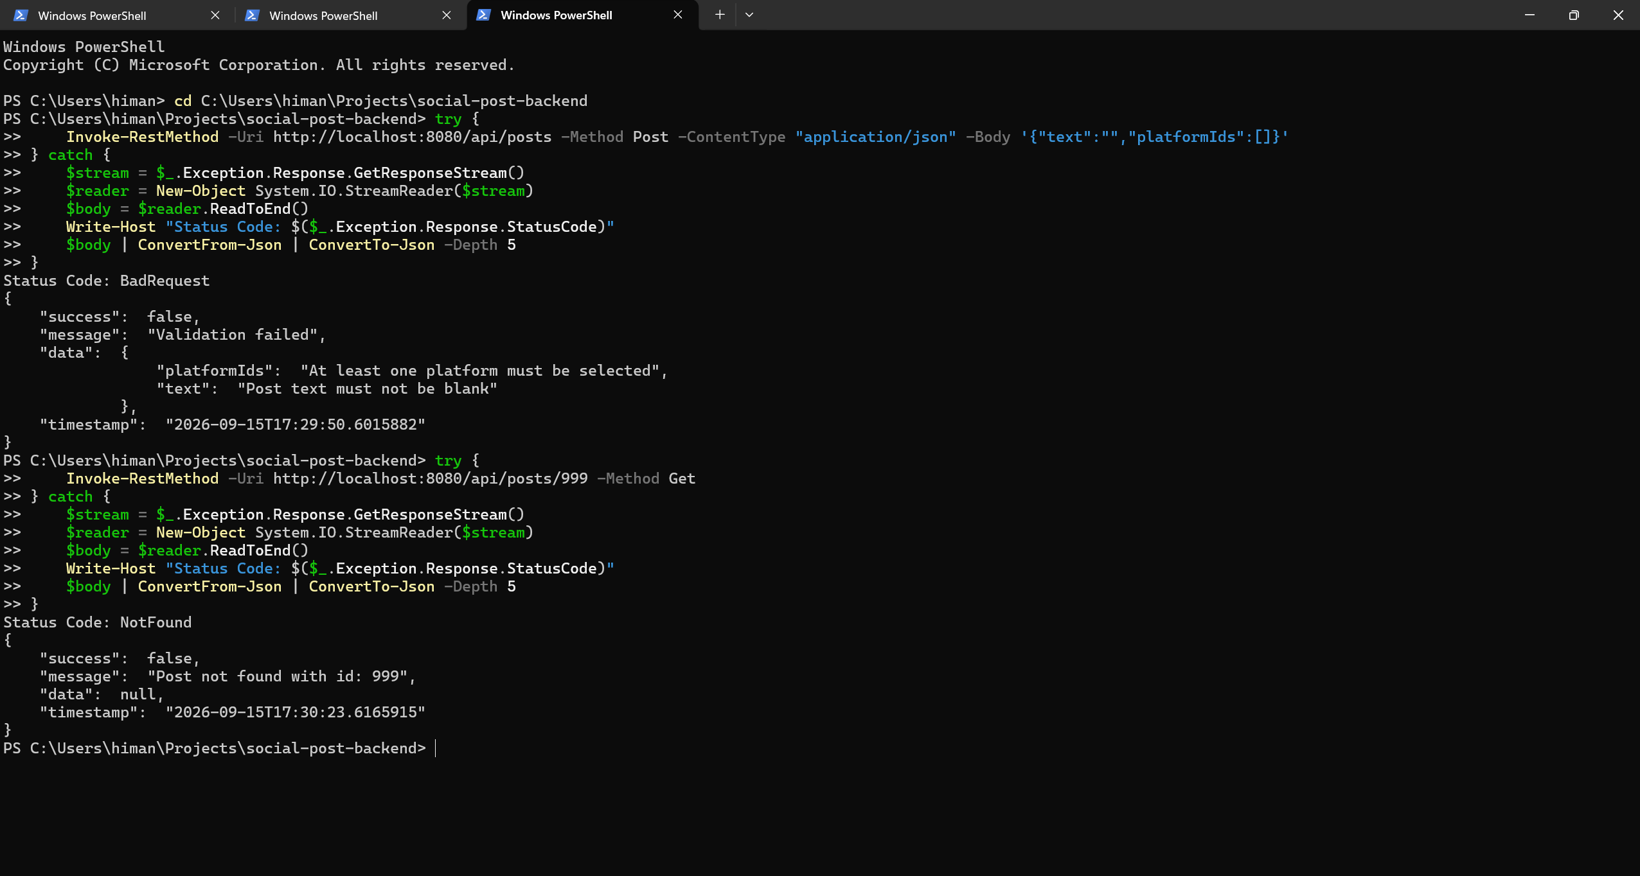
Output 2: AFTER – Clean, Standardized Error Envelopes for Bean Validation (400) and Missing Resource (404)
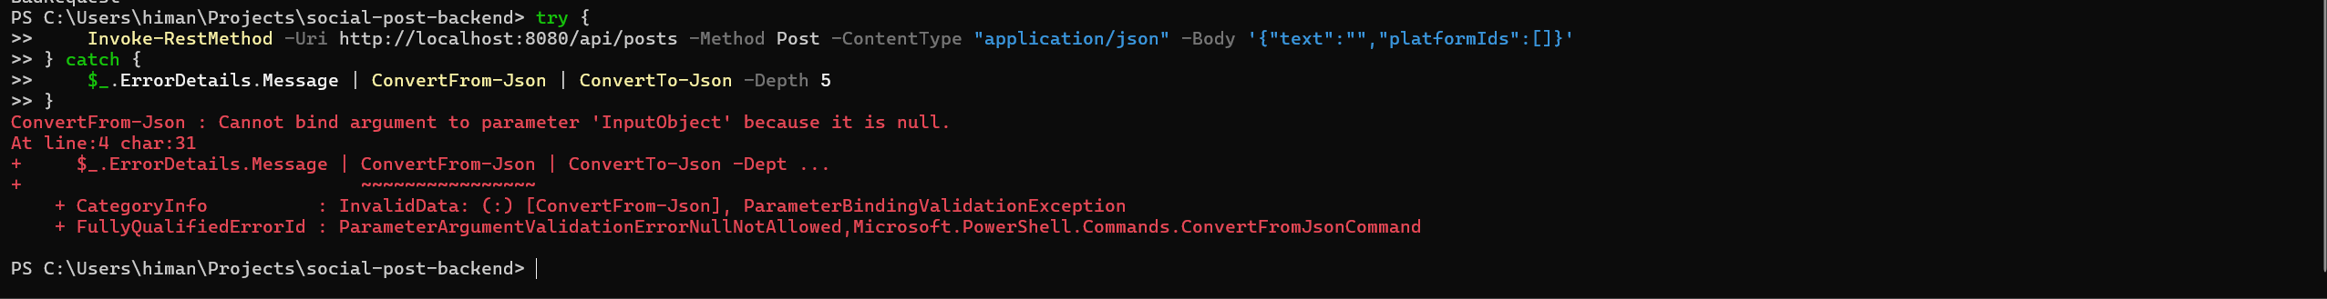
Output 3: Structured Server Logs – Full Request Lifecycle Traced via Unique MDC Correlation IDs
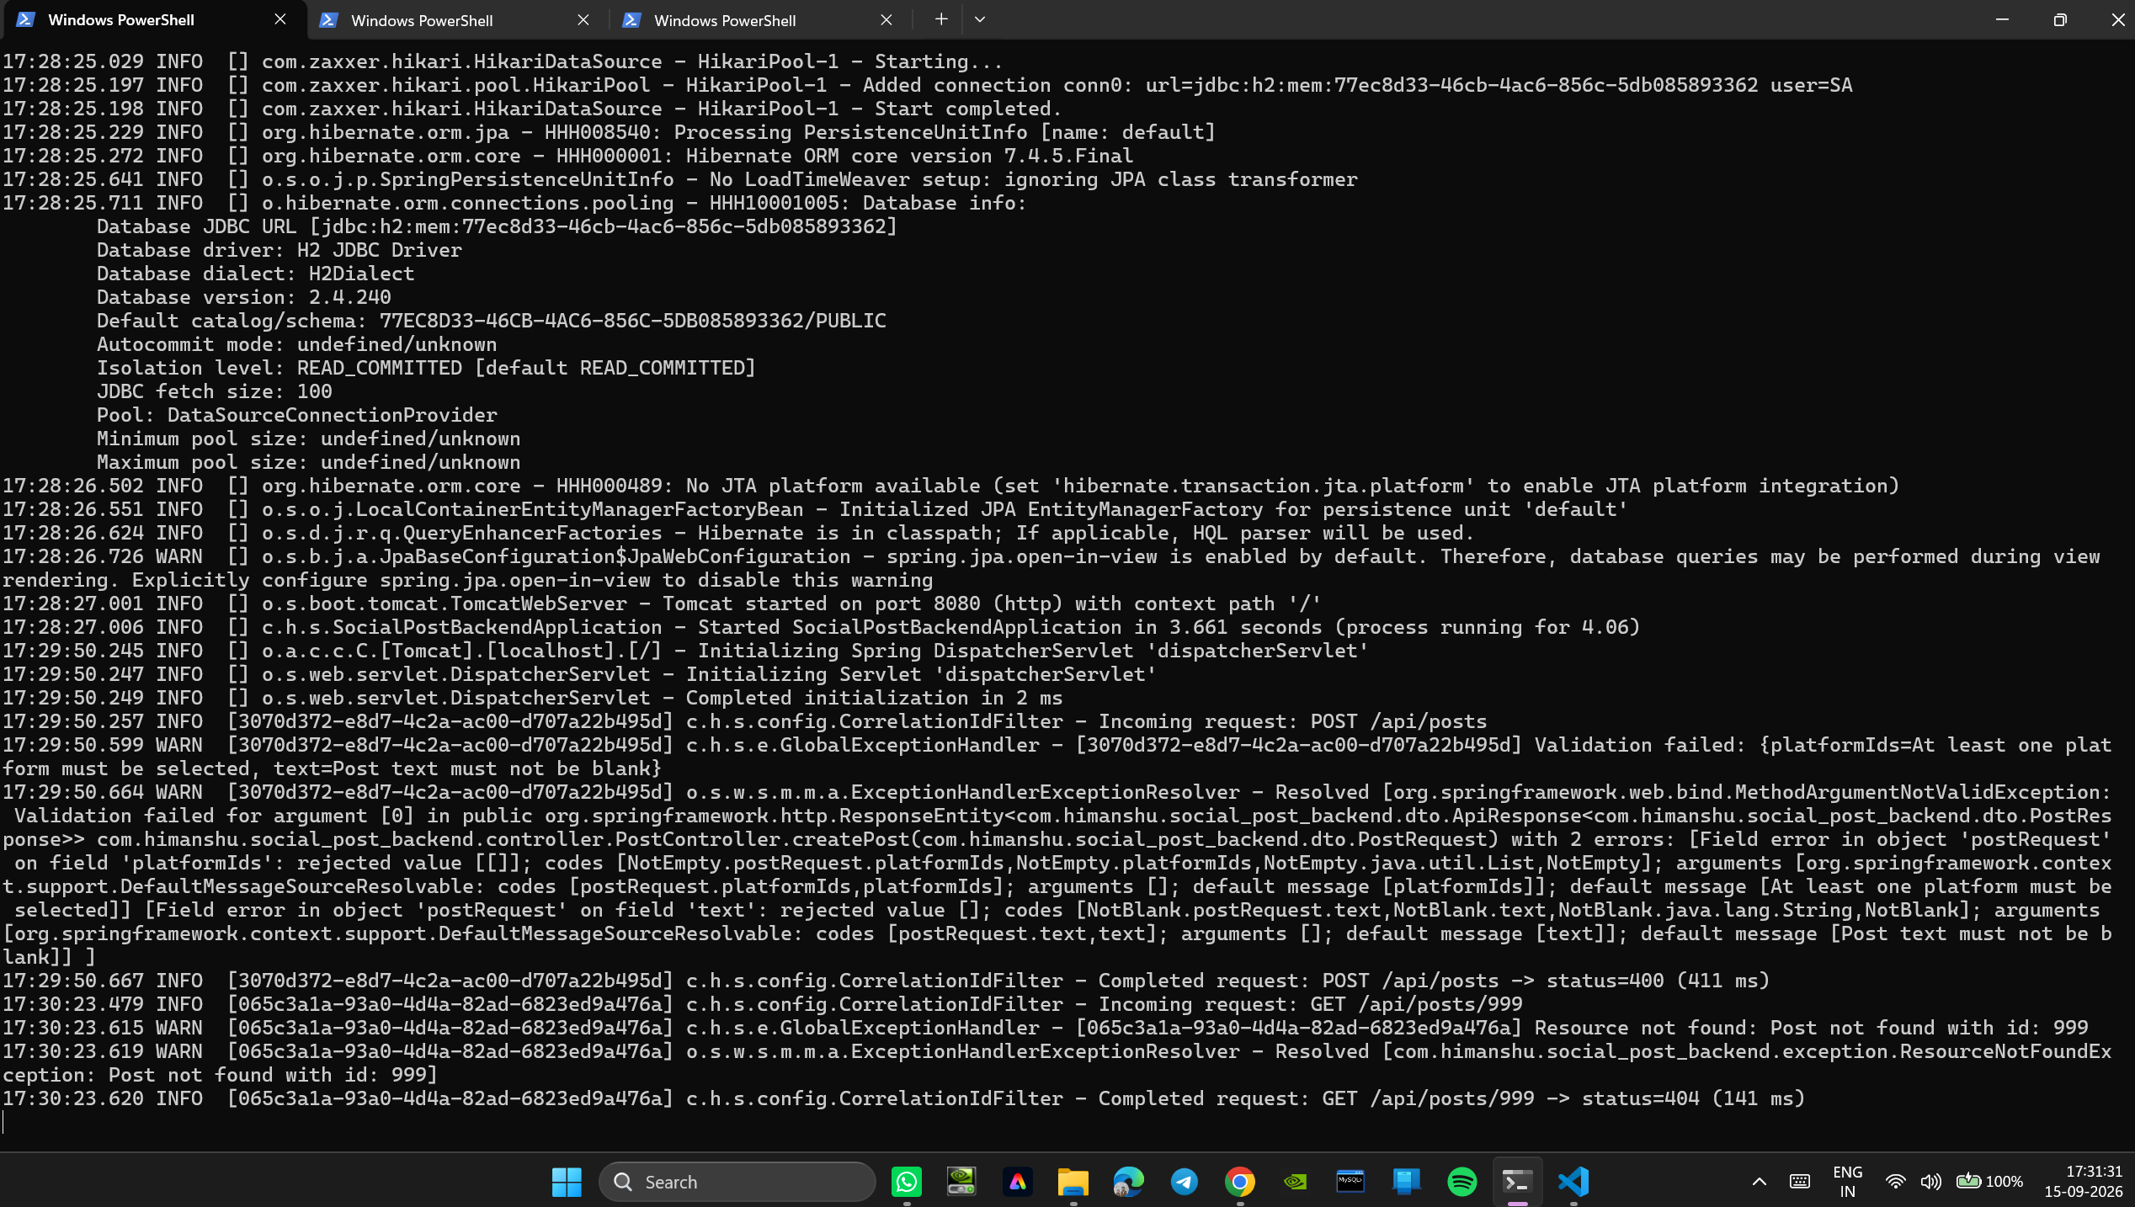
7. Conclusion:
Global exception handling and structured observability mechanisms were successfully established in the backend service. By implementing @RestControllerAdvice, custom domain exceptions (ResourceNotFoundException, BadRequestException) are caught centrally and mapped to uniform ApiErrorResponse payloads, completely eliminating internal stack trace exposure. The CorrelationIdFilter binds unique correlation IDs to SLF4J MDC, enabling seamless tracking of each request from ingress to completion. The resulting backend system achieves enterprise-grade resilience, zero information leakage, and complete diagnostic observability.
8. Learning Outcomes:
• CO3 - BT3: Centralized error response handling using @RestControllerAdvice and custom domain exception hierarchies.
• CO3 - BT3: Engineered uniform error payloads (ApiErrorResponse) preventing stack trace exposure and internal vulnerability leaks.
• CO3 - BT3: Implemented OncePerRequestFilter to intercept incoming requests and manage cross-cutting servlet filters.
• CO3 - BT3: Leveraged Mapped Diagnostic Context (MDC) in SLF4J/Logback for end-to-end request tracing using correlation IDs.

